Chapter III

Methodology
This chapter details the approach and analytical framework to evaluate and optimize passenger flow forecasting, specifically at airport security checkpoints. To provide a structural roadmap for this investigation, the methodology is organized into five components:
- Research Approach: Establishes the theoretical framework, research variables, hypotheses, experimental design, and the technical apparatus utilized.
- Sample: Outlines the multi-tiered macro and micro sampling frameworks used to categorize physical checkpoint environments and terminal architectures.
- Sources of Data: Identifies the primary authorized data repositories supplying the longitudinal datasets.
- Validity: Addresses and controls internal and construct threats, specifically related to passenger flow bias and screening lane heterogeneity.
- Treatment of Data: Details the sequential pipeline used to ingest, clean, standardize, and align the data sources.

Research Approach
The study uses an exploratory, sequential, quantitative design to systematically assess the predictive accuracy and operational utility of distinct forecasting approaches for passenger flow forecasting at airport security checkpoints. While this study evaluates a broad range of frameworks – including static deterministic baselines – it asserts that to truly optimize checkpoint flows, terminal subsystems (i.e., check-in, security screening, and boarding) must ultimately be treated as a stochastic queuing network capable of absorbing dynamic, schedule-driven variability (De Neufville & Odoni, 2014). The primary objective is a comparison of three model families (Figure 1): deterministic baselines, probabilistic and data-driven models, and hybrid frameworks. Deterministic baselines serve as reference cases based on historical averages and scheduled operations. Probabilistic and data-driven models include methods such as SARIMA, LSTM, and random forest models that are designed to capture temporal variation. Hybrid frameworks combine queueing theory with exogenous operational data to reflect both system structure and observed schedule effects.
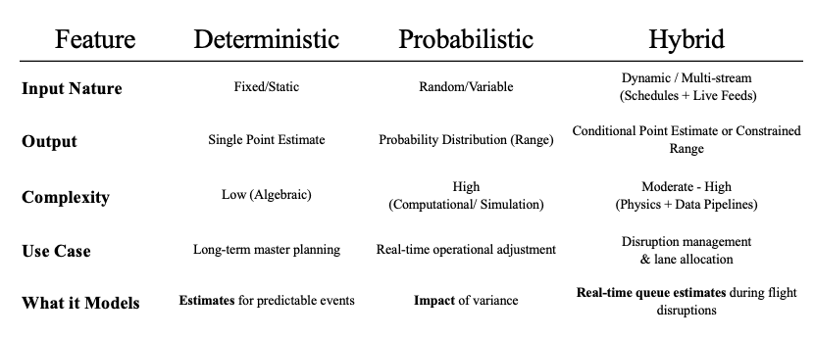
Figure 1. Model Families
The predictive capabilities of each model configuration focus on three core performance measures: robustness, resilience, and generalizability. In this investigation:
- Robustness: Consistency and precision under nominal on-time operating conditions and routine daily operations.
- Resilience: Stability, error boundedness, and speed of recovery after severe exogenous operational disruptions.
- Generalizability: Performance across different airports or terminal layouts under zero-shot spatial transfer without local retraining.

Core Research Variables
Independent variables consist of Scheduled flight departures, actual flight performance data, terminal structure categories, and origin-and-destination passenger ratios. Dependent variables include TSA checkpoint throughput, queue wait times, and bottleneck formation rates. Comparative predictive model performance across the candidate models will serve as a secondary outcome.

Research Hypothesis
The Asymmetric Trade-Off $H_{1}$ : Across the candidate modeling paradigms evaluated following four-tiered purposive filtering (deterministic flight schedules, supervised machine learning, and dynamic two-stage hybrid), no individual approach will prove superior across all three performance measures (robustness, resilience, and generalizability); rather, each modeling paradigm exhibits distinct operational strengths and stark asymmetric trade-offs:
Dimension 1: Robustness
(Routine Operations Target: Lowest ${\text{RMSE}}_{\text{routine}}$ and ${\text{MASE}}_{\text{routine}}<0.700$):
- Hypothesis $H_{1\text{A}}$: Under nominal operating conditions ($\text{DepDelay}<15\text{ min}$, zero cancellations), the Supervised Machine Learning Model (Model 2) and the Dynamic Two-Stage Hybrid Model (Model 3) will successfully achieve the robustness target (${\text{MASE}}_{\text{routine}}<0.700$) by capturing non-linear passenger show-up and flight timing interactions, whereas the Naive Baseline Control and Deterministic Flight Schedule Model (Model 1) will fail the robustness threshold ($\text{MASE}≥0.94$). Machine learning (Model 2) will deliver a computationally lightweight, Pareto-efficient routine solution with zero feedback compute latency.
Dimension 2: Resilience
(Severe Disruption Target: Recovery Multiplier $R_{\text{RMSE}}≈1.00$, Lowest ${\text{MASE}}_{\text{shock}}$, and $\text{TTR}<4.0\text{ hours}$):
- Hypothesis $H_{1\text{B}}$: Under severe operational disruptions ($\text{DepDelay}≥45\text{ min}$ or cancellations $≥5$), the Dynamic Two-Stage Hybrid Model (Model 3) will be the sole architecture to satisfy the resilience target ($R_{\text{RMSE}}≈1.00,R_{\text{MASE}}≈1.00,\text{TTR}<4.0\text{ h}$) due to live 1-step error innovation feedback ($e_{t-1}$). Pure machine learning (Model 2) will suffer severe performance degradation ($R≥2.0$) due to the Empty Checkpoint Fallacy (failing to recognize stranded passenger crowds waiting in the concourse), while deterministic schedules (Model 1) will remain blind to downstream delay cascades.
Dimension 3: Generalizability
(Zero-Shot Spatial Transfer Target: Relative Transfer Ratio $\text{RTR}≈1.00$ and $Δ{\text{MASE}}_{\text{transfer}}≤10.0\%$):
- Hypothesis $H_{1\text{C}}$: Under zero-shot cross-airport transfer without local retraining (e.g., deploying from Newark to LaGuardia), the Deterministic Flight Schedule Model (Model 1) will decisively satisfy the generalizability target ($\text{RTR}≈1.00,Δ\text{MASE}≤10.0\%$) because published flight schedule convolution is strictly invariant to local terminal layout. Conversely, the Dynamic Hybrid (Model 3) will decisively fail the generalizability target ($\text{RTR}≫1.00,Δ\text{MASE}>10.0\%$) due to decision tree terminal geometry overfitting (memorization of specific carrier bank timings and gate configurations at the training airport).
Detailed hypothesis formulations, sub-hypotheses (H1a, H1b, H1c), formal mathematical evaluation thresholds, and Diebold-Mariano test specifications are compiled in the Appendix.

Design and Procedures
This investigation follows an exploratory, quantitative, non-experimental design executed across four sequential phases:
- Phase 1: Initial Dataset Analysis: Compiling and analyzing multi-source federal aviation records across the nationwide Top 25 airport network to evaluate baseline traffic patterns and establish the post-pandemic demarcation.
- Phase 2: Filtering and Subset Selection: Executing the four-tiered purposive filtering funnel to isolate a balanced nine-airport cohort of dedicated, single-carrier security screening complexes.
- Phase 3: Model Development and Execution: Engineering lead-lag schedule features, partitioning development and holdout datasets, and calibrating the four predictive modeling paradigms against the 2025 out-of-time holdout.
- Phase 4: Model Results and Evaluation: Benchmarking candidate model performance across robustness, resilience, and generalizability to evaluate the master asymmetric trade-off hypothesis ($H_{1}$).
Design and Procedure Phases

Figure 3: Design and Procedure Phases

Apparatus and Materials
To manage, parse, and evaluate the large datasets required for this study, the following software and computing resources are used:
- Google Antigravity & Python Analytics Stack: The primary computational environment for automated data ingestion, spatial key resolution, relational joins, and machine learning model training.
- Persistent Cloud Data Warehouse: Secure, version-controlled cloud storage maintaining complete conformed master datasets, relational lookup dimensions, and audit logs to ensure scientific reproducibility.
- Microsoft Excel for Mac & Microsoft Power BI: Deployed locally for advanced data transformation, tabular synthesis, and visual validation.

Sample
To construct an empirically rigorous predictive modeling architecture that eliminates temporal and feature lookahead leakage for airport passenger security screening demand, this study synthesized multi-source operational records covering the continuous seven-year period from January 1, 2019 to December 31, 2025. The initial upstream repository captured 67.22 million raw operational transaction records across TSA checkpoint logs, Bureau of Transportation Statistics (BTS) On-Time Performance (OTP), BTS Form 41 Schedule T-100 Segment data, and BTS DB1B/DB1C ticket coupon surveys (see Master Data Table)
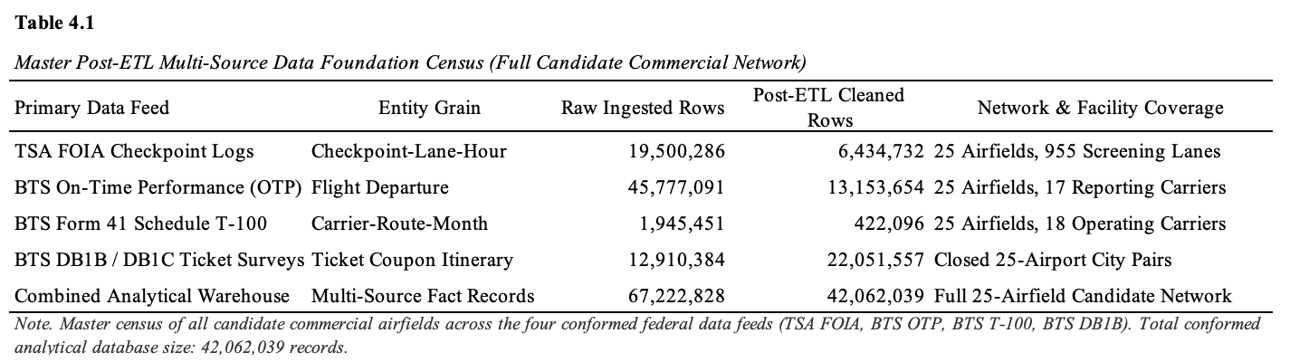
The sample consists of airport checkpoint environments selected to reflect variation in terminal structure and airline dominance. Airports are grouped into structured categories to account for how physical layout influences passenger distribution and checkpoint use (OAG, 2026) Please refer to the Appendix for an in depth review of the different kinds of macro and micro categorizations with examples for each. This strategy is intended to support comparison across terminal types and carriers rather than to claim complete uniformity across airports and airlines.

Four-Tiered Purposive Filtering Pipeline
To systematically isolate the direct operational link connecting airside flight schedules to landside security checkpoint demand, candidate airfields were filtered through a four-tiered purposive funnel, as detailed in the Filtering Pipeline Table.
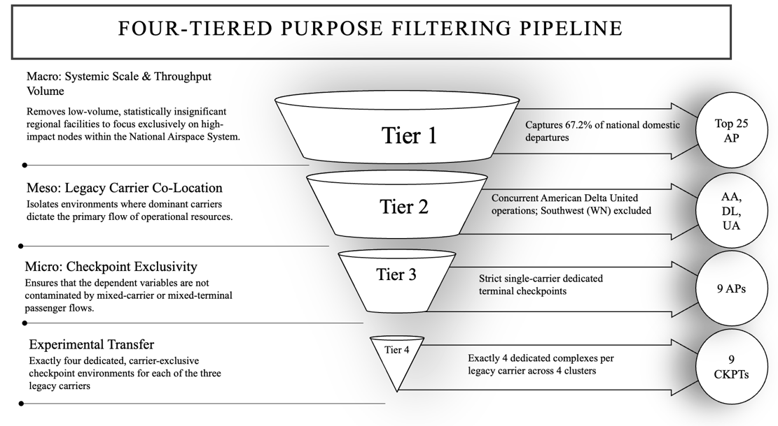
Tier 1: Macro Filter (Scale and Congestion Regimes). The macro filter restricts the initial sampling universe to high-volume commercial airfields where heavy passenger traffic intensity routinely approaches screening capacity, generating the non-linear queuing delays and buffer depletion necessary to train and validate congestion-aware models.
Tier 2: Meso Filter (Airspace Shock Invariance). The meso filter requires candidate environments to operate concurrent domestic mainline services by American Airlines, Delta Air Lines, and United Airlines under identical regional meteorological and air traffic management conditions, neutralizing exogenous airspace disruption confounders while excluding low-cost carrier churn.
Tier 3: Micro Filter (Carrier Checkpoint Isolation). The micro filter restricts analysis to terminal environments where carrier-exclusive gate footprints map directly to dedicated security screening checkpoints, eliminating inter-carrier schedule collinearity and multi-airline passenger crosstalk.
Tier 4: Factorial Cohort (Orthogonal Factorial Balance). The factorial cohort establishes a balanced experimental matrix across the legacy carriers and terminal structural archetypes, ensuring factorial symmetry and preventing geographic or facility-specific bias in cross-airport model evaluations.
Temporal Scope and Boundary Definition
To ensure structural modeling integrity, the temporal boundaries of this sample exclude the systemic operational volatility induced by the COVID-19 pandemic (Sun et al., 2021; Gao, 2022). While a baseline 'post-pandemic' operational era is provisionally considered as beginning January 1, 2023, an exploratory analysis is performed during data preprocessing to refine this demarcation due to varying definitions of ‘post-pandemic’ (ICAO, 2024; Centre for Aviation, 2025). This preprocessing step evaluates pre-pandemic baseline patterns against longitudinal 2019–2025 data to pinpoint the empirical inflection point where system throughput and schedule deviations returned to steady-state normalization.

Sources of Data
Operational data are compiled from four primary authorized federal repositories covering the longitudinal study period: Transportation Security Administration (TSA) Freedom of Information Act (FOIA) Security Screening Checkpoint Logs, Bureau of Transportation Statistics (BTS) On-Time Flight Performance records, BTS Form 41 Schedule T-100 Domestic Segment Data, and BTS Origin and Destination Ticket Surveys (DB1B). Together, these longitudinal feeds capture hourly physical screening counts across checkpoint lanes, individual domestic flight movements and delay cause decompositions, aircraft seating configurations and route load factors, and quarterly passenger itinerary connection ratios. Complete repository profiles, entity grains, and operational attributes are detailed in Table A.3 and the Appendix.

Validity
A major threat to internal model validity is the presence of connecting passengers who remain airside and do not pass through a public checkpoint in load factor data. Including them in checkpoint demand estimates inflates predicted originating demand. To reduce this bias, origin-and-destination data is used to estimate and remove connecting traffic from passenger flow calculations. Construct validity is also affected by checkpoint heterogeneity, as the raw lane counts obtained from TSA Throughput data combine different screening modes, such as TSA PreCheck, and their corresponding processing rates. Please refer to the appendix for details on validity
Treatment of the Data
Data processing follows a sequential pipeline. First, raw BTS and TSA files are exported and parsed using Python on the institutional computing environment. Timestamps are standardized to a uniform operational clock matching local airport solar time. Scheduled overnight checkpoint closures are preserved as true operational structural zeros, and advance cancellations are separated from tactical cancellations to preserve information causality. Lastly, flight departure times are aligned with passenger lead-time assumptions from ACRP Report 40 and merged with hourly TSA throughput intervals to create a final modeling dataset, with the exhaustive ETL data engineering protocol detailed in the Appendix.

